**Database Schema**

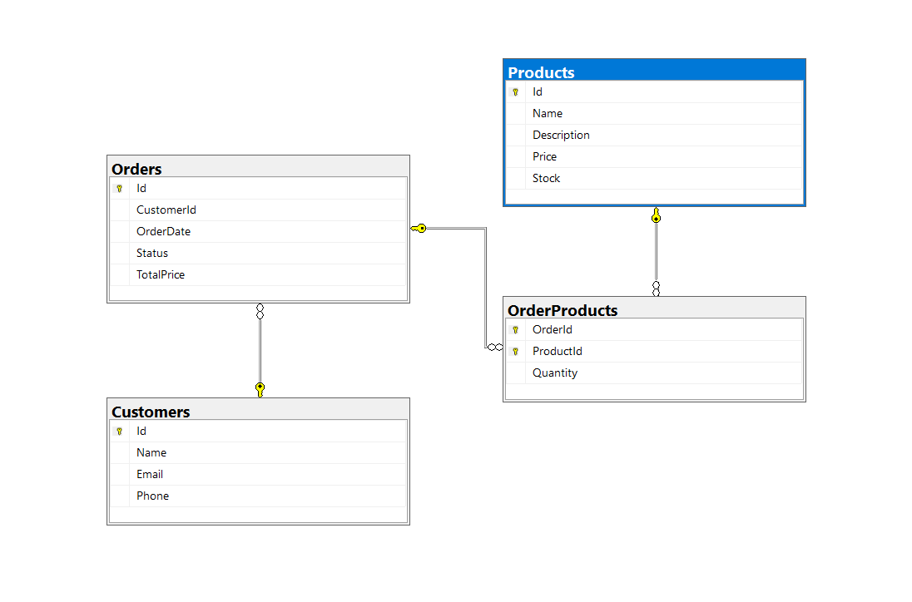

**Database Tables**

* **Customers**

|  |  |  |
| --- | --- | --- |
| Column | Type | Constraints |
| Id | int | Primary Key, Identity |
| Name | nvarchar(100) | Not Null |
| Email | nvarchar(100) | Not Null, Unique |
| Phone | nvarchar(15) | Nullable |

* **Products**

|  |  |  |
| --- | --- | --- |
| Column | Type | Constraints |
| Id | int | Primary Key, Identity |
| Name | nvarchar(100) | Not Null |
| Price | float | Not Null |
| Stock | int | Not Null |

* **Orders**

|  |  |  |
| --- | --- | --- |
| Column | Type | Constraints |
| Id | int | Primary Key, Identity |
| CustomerId | int | Foreign Key → Customers(Id) |
| OrderDate | datetime | Not Null |
| Status | nvarchar(20) | Default('Pending') |
| TotalPrice | float | Not Null |

* **OrderProducts (Many-to-Many)**

|  |  |  |
| --- | --- | --- |
| Column | Type | Constraints |
| OrderId | int | FK → Orders(Id), PK (composite) |
| ProductId | int | FK → Products(Id), PK (composite) |
| Quantity | int | Not Null |